# 2011 – Castlemaine Seed Fishing Report

Note: This report was compiled by the Secretariat to the BGMCF using data provided by the SFPA, BIM and the Marine Institute

# Table of contents

**1.0 Permitted Tonnage**

**2.0 Opening of the Fishery**

**3.0 Vessel Activity**

**4.0 Control Measures**

**4.1 Licensing and Authorisation of vessels**

**4.2 Recording and Notification of effort and catch take**

**4.3 Monitoring, Control and Surveillance**

1. **Habitat monitoring**

**5.1 Introduction**

**5.2 Methods**

**5.2.1 Intertidal mussel cover**

**5.2.2 Seagrass**

**5.3 Results**

**5.3.1 Seagrass**

**5.3.2 Mussel Coverage**

**6.0 Conclusions and recommendations**

# 1.0 Permitted Tonnage

In compliance with the Fisheries Natura Declaration No. 1 of 2011, the permitted area was determined by the Minister, based on BIM surveys of mussel spat fall ( July and October 2011) and only included areas of outer Castlemaine Harbour that were assessed for sub-tidal mussel seed fishing in the Appropriate Assessment report of April 2011.

The total estimated biomass of mussel seed in the permitted area was documented by BIM on the 10/10/11 and was 3000 tonnes (See Appendix 1).

# 2.0 Opening of the Fishery

The signing of the Fisheries Natura Declaration 2011-2016 (Castlemaine Harbour) allowed for the opening of the Mussel Seed Fishery 2011. This Declaration sets restrictions on the dredging, retaining on board, transplanting and re-laying of Mussel Seed in Castlemaine Harbour.

The fishery was initially due to open nationally on the 19th August 2011 and this was deferred until the 4th of September due to allow available seed to mature. In Castlemaine, operators in the area did not fish until November, this was a voluntary agreement among the fishermen which aimed to maximise the volume and viability of seed mussel resource available.

# 3.0 Vessel Activity

A total of seven vessels were authorised to participate in the Castlemaine Harbour fishery 2011.

Four of these vessels were ‘small’ (<8m) capable of carrying approximately 1-1.5 tonnes of seed and are listed as follows:

* Rebecca (T317A)
* Loco (T318A)
* Amber (T90A)
* Star (T8A)

Due to both the weather and the inaccessibility of the Mussel Seed none of these vessels participated in the transplantation and re-laying of Mussel Seed in 2011.

The other three authorised vessels in the fishery consist of the larger dredgers:

* Western Adventure II (T87A)
* Goede Verwachting (B 931)
* Eben Haezer (WD188A)

These vessels participated in a very limited fishery over a six day period from the 3rd until the19th of November 2011.

The total quantities fished and relayed was 640 tonnes, this represented approximately 22% of the available biomass.

# 4.0 Control Measures

Monitoring and Inspections of the Mussel Seed Fishery were carried in accordance with the SFPA Cromane Fishery Control Plan 2011.

## 4.1 Licensing and Authorisation of vessels:

Initial inspections of participating vessels began in April 2011 when the vessel owners were required to submit ‘Expression of Interest’ forms to DAFM. In accordance with the requirements of these applications SFPA Dingle inspected all vessels with regard to licensing, Black Box and VMS installation (on >12m vessels) as well as Hold capacity plans and Hold markings. Upon the opening of the fishery the three participating vessels were inspected to ensure the Authorisation Document was held on board – the specific ‘take’ amount for each vessel as stipulated in the Authorisations was noted by SFPA Dingle.

All vessels fishing for mussel seed within the Castlemaine Harbour Special Protection Area and Special Area of Conservation were in possession of a Fisheries Natura Permit (permit) issued under Regulation 5 of the European Communities (Natural Habitats and Birds) (Sea-Fisheries) Regulations 2009 (S.l. No. 346 of 2009).

## 4.2 Recording and Notification of effort and catch take:

Prior to the opening of the fishery SFPA Dingle issued the authorised vessels with Spat Books - the three larger vessels were also inspected to ensure they had an EU Logbook on board. Vessel owners were reminded of the requirement to submit EU Logsheets within 48hrs of each fishing operation and Spat Book records to be submitted to SFPA Dingle on a weekly basis. All three participating vessels complied with these requirements. The FMC received notifications 2 hours prior to discharge detailing vessel ID, seed quantities onboard and vessel intention. These notifications were immediately send from the FMC to SFPA Dingle personnel.

## 4.3 Monitoring, Control and Surveillance:

Shoreside monitoring was conducted by SFPA Dingle to ensure that no fishing activity took place before the opening of the fishery. Subsequent to the opening of the fishery daily surveillance ensured only authorised vessels participated in the fishery. The three larger vessels were observed operating exclusively on the mussel seed beds in an area north of Rosbehy Point prior to relaying to inner Castlemaine Harbour.

Subsequent transplantation from the inter-tidal nursery area only took place within the area of Castlemaine Harbour, as defined in the Schedule to Mussel Fishery (Castlemaine Harbour) Order 1979 or within the boundaries or limits of an aquaculture licence in Castlemaine Harbour issued under the Fisheries

(Amendment) Act 1997 and specified in Condition 2 of the holder's mussel seed authorisation.

No permit holder reached or exceeded the total allowable catch specified in their permits.

# 5.0 Habitat monitoring

## 5.1 Introduction

Appropriate assessment of intertidal relay of mussels in Castlemaine Harbour in 2011 indicated that the proportion of the intertidal area that received relay of mussel might impact on the waterbird assemblage and its use of intertidal habitat in the area and as a result be contrary to the conservation objectives for the SPA. Possible mussel encroachment or siltation on the nearby seagrass bed, to the east, was also a concern.

The impact of an 11% (range 0-42%) mussel cover had been assessed as non significant in the AA but higher % cover was not assessed. If higher % cover occurred as a result of relaying then parallel monitoring of bird populations was recommended during the AA consultation process. If this was found to have a significant effect on bird populations then the % cover would be reduced by removal of mussel from the area.

Two indicators were monitored in response to the AA and the consultation process;

1. The percentage of the intertidal relay area used by the local co-operative what was covered in mussel
2. The distribution of seagrass east of the mussel relay area

## 5.2 Methods

5.2.1 Intertidal mussel cover

The intention was to complete aerial surveys of the entire intertidal area and to estimate mussel cover from the resultant images. During 2012, although two flights were successfully completed, finding a suitable combination of low tide, daylight hours, windspeeds of <7m.sec-1 and no rain proved elusive during the 2012 Irish summer.Two flights were completed on May 30th which covered parts of the intertidal relay area and the seagrass bed (Fig 1). Sea grass was not evident in the resultant images as shoot density and size was low at the beginning of the growing season. Aerial images were obtained using the Swinglet Cam Unmanned Aerical Vehicle (UAV) from Sensefly (http://www.sensefly.com/products/swinglet-cam/). Flight planning and communication with the UAV was managed using e-mot-ion® software on a toughbook PC. Flight altitude was approximately 100m resulting in an image resolution of 4.4cm.pixel-1. Individual images overlapped geographically by 60% to ensure smooth meshing and mosaic production. The image mosaic of the fly over areas was produced by Sensefly post flight services following image geo tagging using flight log information recorded for each image during the flight. Mussel cover in the area surveyed by the UAV was estimated using the unsupervised classification procedure in the image analysis tool in Spatial Analyst in ArcGIS 10.0. This is a standard image analysis process that classifies each pixel in the image according to its Red Green Blue (RGB) spectral signature. The two mosaics obtained traversed parts of the seagrass bed, the area between the sea grass bed and the intertidal relay area and the relay area. Percentage mussel cover was calculated for these areas separately.

To cover areas not surveyed by the UAV a ground survey was also completed on May 29th and 30th 2011. In this case 3 x 3m quadrats were placed randomly at approximately 100m distance along north south transects in the relay area and west of the relay area close to the sea grass bed (Fig 1). The percentage mussel cover in each quadrat was estimated and position logged using Trimble Nomad GPS units. On July 7th core samples were taken to profile the size distribution of mussel in mussel patches and to estimate numbers and biomass of mussel per square meter. These data could be used to estimate the biomass of mussel on the intertidal area in combination with the aerial survey data (Fig. 1).

5.2.2 Seagrass

The annual EPA survey of seagrass in the area usually takes place during in August. In 2012 the survey is planned for early September and is not available for this report. The eastern border of the sea grass bed was mapped on August 8th by the Marine Institute by walking the border and recording GPS position every second. The resultant line was superimposed on earlier EPA survey data to determine if the eastern border of the seagrass bed had changed (Fig. 1). This is the main feature of interest in relation to possible encroachment of mussel into the seagrass bed. In addition observations of mussel cover in the seagrass bed were made during the walkover and some of the aerial images obtained in May also traversed the seagrass bed. 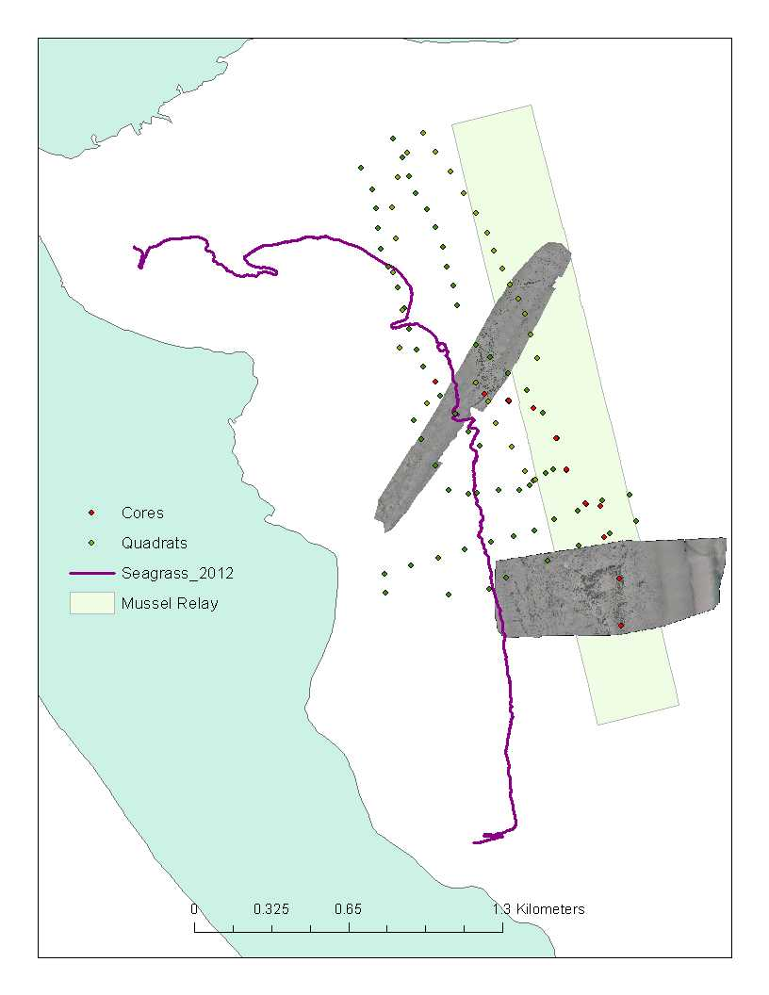

Fig. 1. Summary of habitat monitoring data obtained in 2012 in the seagrass and intertidal mussel relay area in Castlemaine Harbour. Grey areas are UAV mosaics of intertidal habitat obtained on May 30th. Quadrat and core data of mussel cover and mussel size distribution respectively were obtained in May and July. The eastern extent of the seagrass bed was mapped on August 8th.

## 5.3 Results

5.3.1 Seagrass

* The location of the eastern border of the seagrass bed in 2012 was similar to that recorded by the EPA in 2009-2011 (Fig 2). An area on the eastern extent at the northern half of the bed recorded in 2009 was not present in 2010-2012.
* The border of the sea grass bed is clearly identifiable, is irregular, especially in the northern section, and is cut by channels draining the upper shore areas (Fig. 3)
* From observations on Aug 8th shoot density was lower in the northern part of the bed than in the southern part
* There are small patches of mussel in the eastern area of the seagrass bed especially in the mid section. These are adult mussels with fucoid cover (Fig 3).
* There are very small (<30cm diameter) patches of mixed mussel and cockle shell with sparse fucoid cover throughout the sea grass bed (Fig. 4)

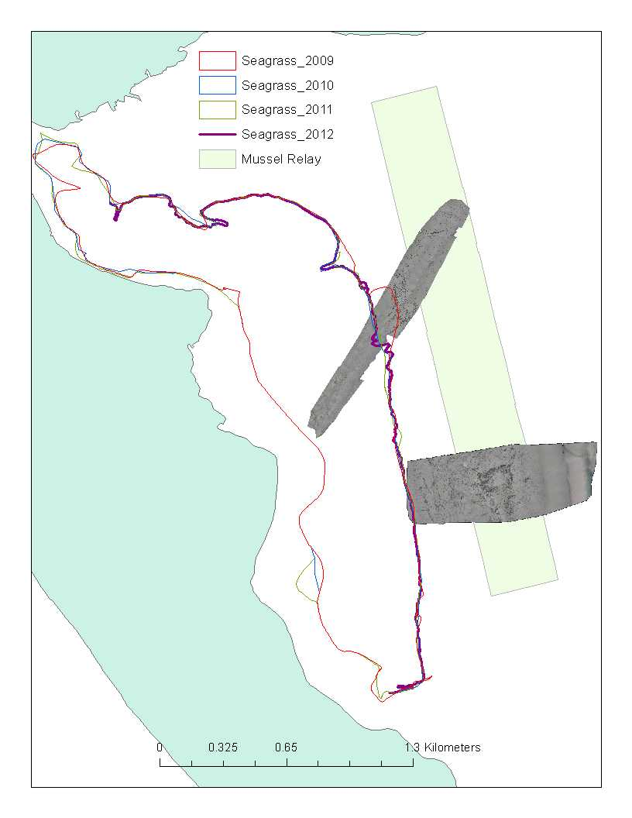

Fig. 2. Outline of the intertidal seagrass bed in Castlemaine Harbour in 2009, 2010 and 2011 (EPA data) and the eastern extent of the bed in 2012 (MI data).

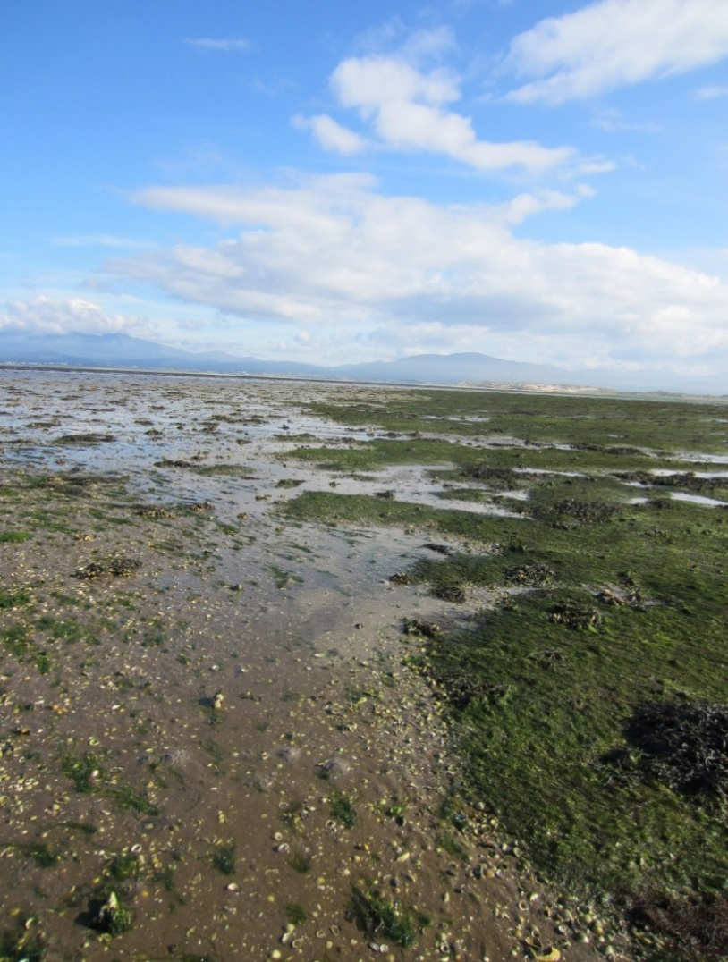

*F*ig. 3. View to the south of the eastern edge of the seagrass bed in Castlemaine Harbour. Shell debris in the left foreground is mainly cockle shell. Patches of mussel with fucoid cover can be seen in the seagrass bed.

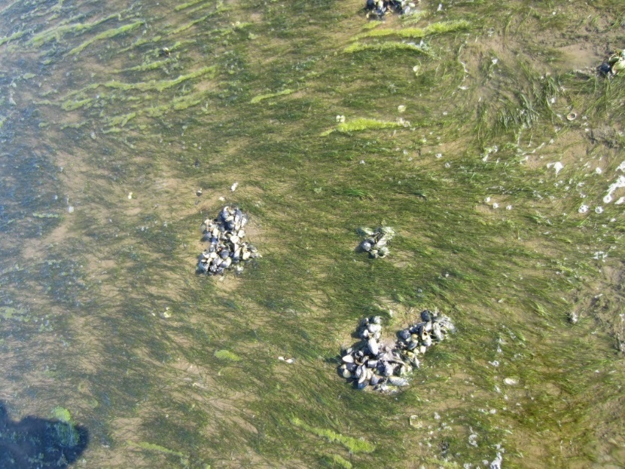

Fig. 4. Patches (<30cm) of mixed mussel and cockle in seagrass at Castlemaine Harbour on August 8th 2012.

## 5.3.2 Mussel Coverage

## UAV images

* Image quality from the UAV is high and capable of identifying and resolving mussel patches less than 0.5m in diameter.
* Mussel is clearly identifiable from sediment in the images. Mussel mud, seeping from the edges of the mussel patches is also identifiable and has a different spectral signature to the mussel and surrounding sand. Unsupervised classification analysis of the image successfully resolved mussel, mussel mud and sand (Fig. 5, 6).
* Mussels patches were generally comprised of adult mussels with fucoid seaweed cover
* Mussel cover in the intertidal relay area was 16.1% and 5.8% of the intertidal area in the southern and northern images respectively (Table 1, Fig. 7)
* Mussel cover in the area between the seagrass bed and the intertidal relay area was 9.7% and 11.3% in the southern and northern images respectively (Table 1, Fig. 7)

Table 1. % mussel cover in the intertidal mussel relay and area and in the area between the sea grass bed and the relay area in two UAV images taken on May 30th 2012.

|  |  |  |
| --- | --- | --- |
| Image | In Relay area | Between sea grass and relay area |
| Aerial 1 (south) | 16.10 | 9.70 |
| Aerial 2 (north) | 5.80 | 11.30 |

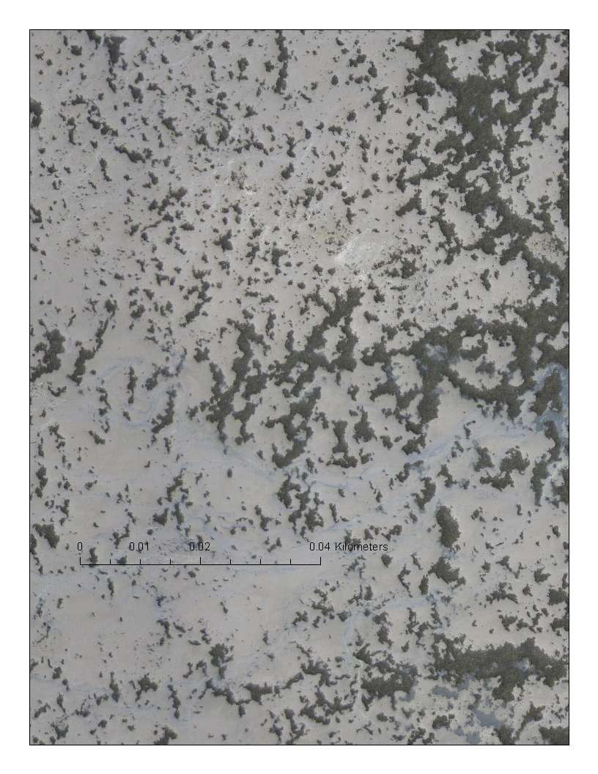

Fig. 5. Zoomed+ UAV image of intertidal mussel patches on sand at Castlemaine Harbour on May 30th. Mussels are dark patches. Sand is lightest grey. Darker grey areas surrounding mussel patches is mussel mud. Note scale bar of 40m. Patches of mussel less than 0.5m in diameter are visible

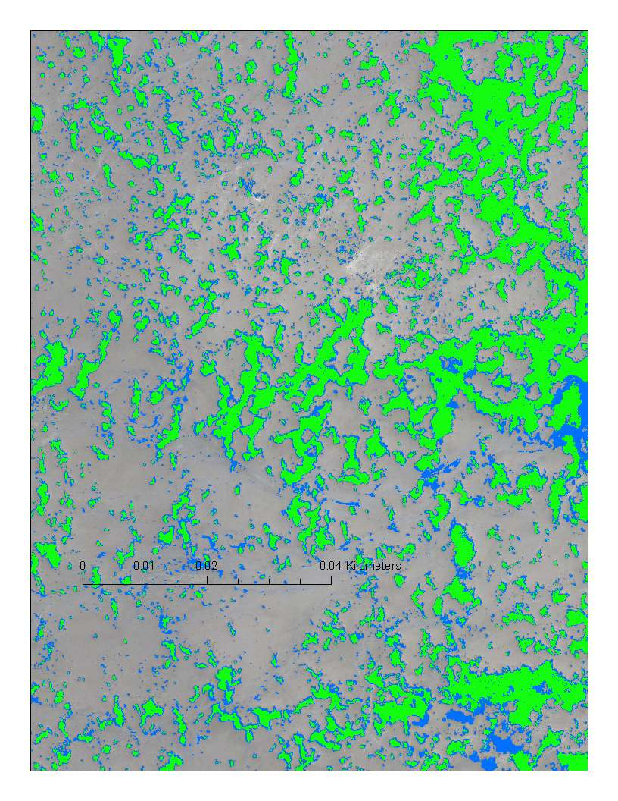

Fig. 6. Image analysis (unsupervised classification) of UAV image of intertidal mussel patches on sand at Castlemaine Harbour on May 30th (Fig 5). Mussels patches are green. Sand is grey. Mussel mud is blue. Note scale bar of 40m. Patches of mussel less than 0.5m in diameter are visible

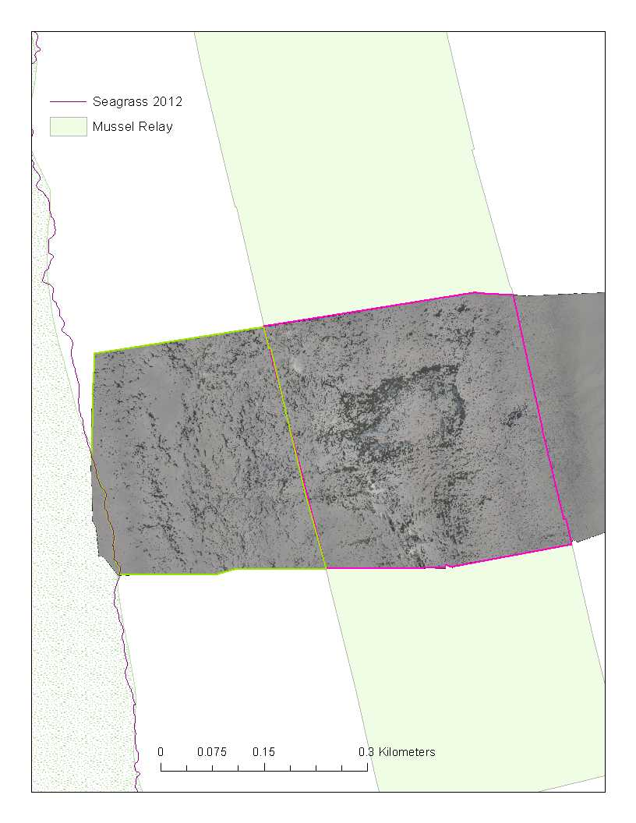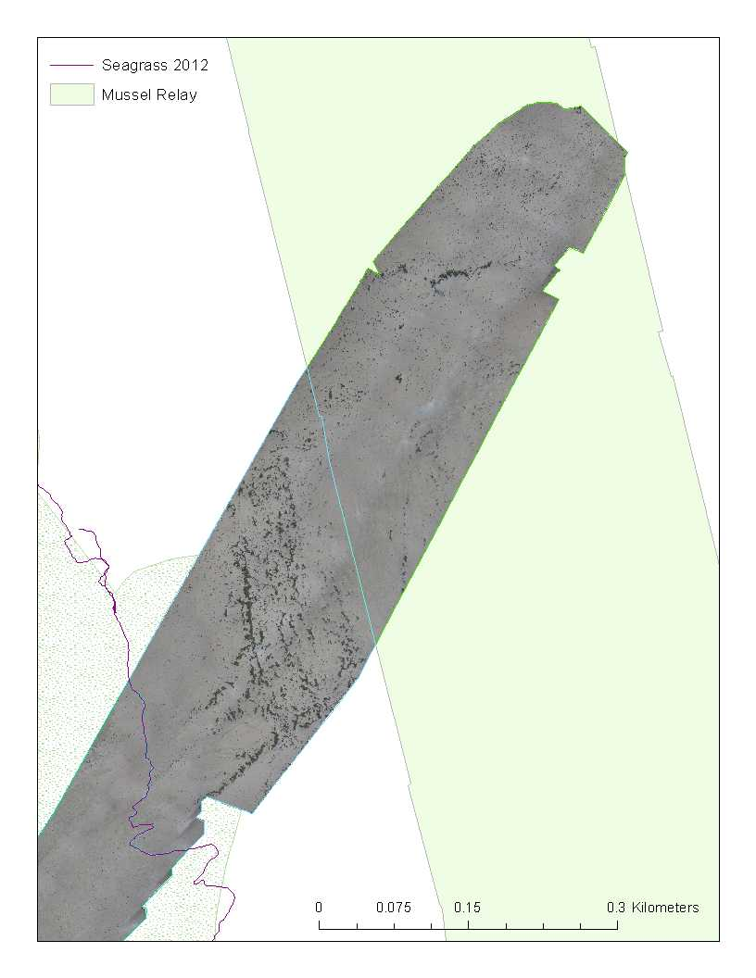

Mussel in

relay area

Mussel between sea grass and

relay area

***Aerial image 1***

***Aerial image 2***

Mussel in

relay area

Mussel between sea grass and

relay area

Fig. 7. Segments of aerial images 1 (north, Fig. 1)) and 2 (south, Fig. 1) in the intertidal relay area and between the seagrass bed and relay area in Castlemaine Harbour. % mussel cover for each segment is in Table 1.

## Mussels: quadrat data

* Quadrat data in the intertidal relay area and west of this area towards the sea grass bed indicates an average % mussel cover of 15±26 and a range of 0-100% i.e. there are 3x3m square areas with no mussel and 3x3m square area with 100% mussel cover.
* Mussel cover in the relay area was 27±35%
* Mussel cover between the relay area and the edge of the seagrass bed was 15±27%
* Mussel cover in the seagrass bed was 5±12%
* Mussel cover was lighter (7±12%) in the northern half of the area surveyed by quadrat than in the south (22±33%) (Fig. 8 for photograph of northern section)

Ground level photograph looking east of the northern section of the intertidal relay area. Mussel cover is 7%. 



Fig. 8. Ground level photograph looking east of the northern section of the intertidal relay area. Mussel cover is 7%.

## Mussels - Core data

* Within mussel patches the density and biomass of mussels was 1012±573 mussels.m-2 and 13.1±7.5kgs.m-2 respectively.
* The modal length of mussels in core samples was 38mm (Fig. 7)
* If the biomass of seed relay per square meter of intertidal area is similar to the biomass recorded in core samples then the relay of 640 tonnes of seed in autumn of 2011 would have covered 4.92ha or 5.3% of the 92ha intertidal relay area.

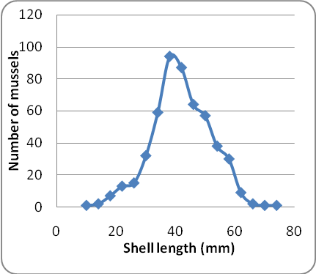

Fig. 8. Shell length distribution of intertidal mussels in Castlemaine Harbour on July 6th 2012.

# 6.0 Conclusions and recommendations

* Permitting, regulatory monitoring and enforcement measures were successful and complied with the terms and conditions of the Fisheries Natura Plan and the Appropriate Assessment
* The extent of the seagrass bed and in particular the location of the eastern border of the bed is stable
* Mussel cover in the intertidal relay area, assessed by analysis of UAV images, was similar to that reported in 2010 (average 12%) and which was subject to AA in 2011. Percentage cover as assessed by quadrat sampling in 2012 was higher than reported in 2010 but the 2012 quadrat estimates are very imprecise.
* Given that the % of mussel cover in 2012 was similar to that assessed in the 2011 appropriate assessment and the extent of the seagrass bed is similar to previous years 2009-2011 no new management actions are required at this point.

# Appendix 1

## Seed surveys

# Seed Mussel Survey Report for Castlemaine Harbour/ Cromane – 12, 13 and 14/07/2011

## Vessel:

MV T’Burke (BIM), Skipper John Murphy, Survey officer Nicolas Chopin

## Equipment:

1 meter dredge, 0.1m2 Day grab, 400 kHz side scan sonar, Roxswath seabed classification system

## Area surveyed:

the channel between Inch Point and Rossbehy point, further North in the channel, East of Minard Head in Dingle Bay (see Map)

## Survey Summary:

Following the preliminary survey at the start of July, a full survey has been carried out in the channel to see if there was further settlement. Very recent spat was observed in the channel in the previous survey on two locations (see map). Few more tows were made around those areas, but no extra signs were found apart from few full grown mussels (Tows TD18 and TD20 on the map). Those large mussels seems very scattered on the ground, no large extent were spotted on the side scan sonar data or the Roxswath.

The hardness of the seabed made the grab attempt difficult, but one stone was caught with some spat on (see GD2 on the map).

## Coordinates for spat areas*:*

|  |  |  |  |  |  |
| --- | --- | --- | --- | --- | --- |
| ***Area 1*** | **Lat** | **Long** | ***Area 2*** | **Lat** | **Long** |
|  | 52° 5.661' N | 9° 59.523' W |  | 52° 5.971' N | 9° 56.027' W |
|  | 52° 5.606' N | 9° 58.363' W |  | 52° 5.936' N | 9° 55.881' W |
|  | 52° 5.666' N | 9° 58.123' W |  | 52° 5.669' N | 9° 56.244' W |
|  | 52° 5.588' N | 9° 57.784' W |  | 52° 5.541' N | 9° 56.254' W |
|  | 52° 5.549' N | 9° 57.876' W |  | 52° 5.512' N | 9° 56.472' W |
|  | 52° 5.480' N | 9° 58.803' W |  | 52° 5.590' N | 9° 56.691' W |
|  | 52° 5.603' N | 9° 59.527' W |  | 52° 5.762' N | 9° 56.260' W |

The large mussels have an average size of 54 mm; there is around 26 % of waste, mainly small stones and byssus, and around 74 pieces per kilo. Tows and grabs around the location showed that they are spread on a very small area.

Tows outside the channel (tows TD21 and 22 on the map) showed mainly coarse sand with few white clams.

Only a limited amount of small starfish was found in the surveyed area.

Investigations further North in the channel (toward Island Point and the car park) were unsuccessful, the ground was very rough with rocks.

Rock seed was observed on the shore around Minard Head (North side of Dingle Bay), a tow was made at the border rock/sand on 17 meters deep but came back empty

## Bottom type:

Mainly round stones and old oyster shells, some seaweed, few areas with fine unsettled sand in the channel. Rocks further North. Fine sand around 16/17 meter deep to Minard Head.

## Recommendations:

This survey confirmed what was found in early July (see recommendation in Preliminary report). There is no major fishable seed settlement in the location for the moment. The spat areas should be monitored for growth and predation until a fishable size is reached. A dive survey should be considered in mid August if possible.

Nicolas Chopin

BIM Inshore Survey Officer

22/07/11

**seed mussel bed sample  analysis**

**Cromane / Castlemaine Harbour Seed Mussel Bed Sample Analysis – 10/10/11**

**Equipment:** Day grab (0.1 m2)

Following previous surveys in the area in July and September, a seed mussel settlement was found in the channel between Rossbehy Point and Inch Point. The bed was approximately 26 hectares; the seed on the spot was very small at the time of the last survey, the average size was around 6 mm.

The recommendations on the last report on the area specify that when the seed reached an average size of 12 to 15 mm transplantation would be possible.

New samples were collected on the 7th of October and analysed.

**Samples analysis:**

Figure 1:  Samples Comparison Graph

Figure 1: Samples Comparison Graph

The new samples showed an average size of 10.57 mm, with an average growth of 4.5 mm from the samples collected a month ago. The graph above shows as that the larger population size is around 13 mm. The average waste amount throughout the samples is 18% and there is around 6300 pieces per kilo.

The average weight in the grab samples was between 800 grams to 1 kilogram for 0.1 m2 which represents 10 kg/ m2. This density confirms the video data collected in early September. From that combined data, the estimated top tonnage for this bed is 3000 tons.

**Recommendations:**

The seed on this bed reached the target fixed in the previous seed mussel report for this area (12 to 15 mm on average). The borders of the beds haven’t moved since the last survey but due to the late time in the year, the weather conditions will have more and more effects on this settlement. Therefore it is recommended that the bed be opened on the next available tide

Nicolas Chopin, BIM Inshore Survey Officer – 10/10/2011